**Phase 3 Documentation**

**Program 3.1**

**File name: ​phase3_3.1monthlywise，phase3_3.1weeklywise**

**Description:**

Find the correlation between price movements of different Spot Cryptocurrencies having same currency pair, for example, use all Cryptocurrency and USD pairs first. Plot the heatmap for showing correlation values. Calculate correlation month-wise or week-wise

**Inputs(I have set down all the input so no need to input anything):**

Filetype ​: A or B or C or D

date​: the date in yyyymmdd format

ticker​: the pair to plot

plot: heat plot

**Output:**​ for now they are showed in the file the very end part.

**Sample：**

**Weekly wise Trade USD:**

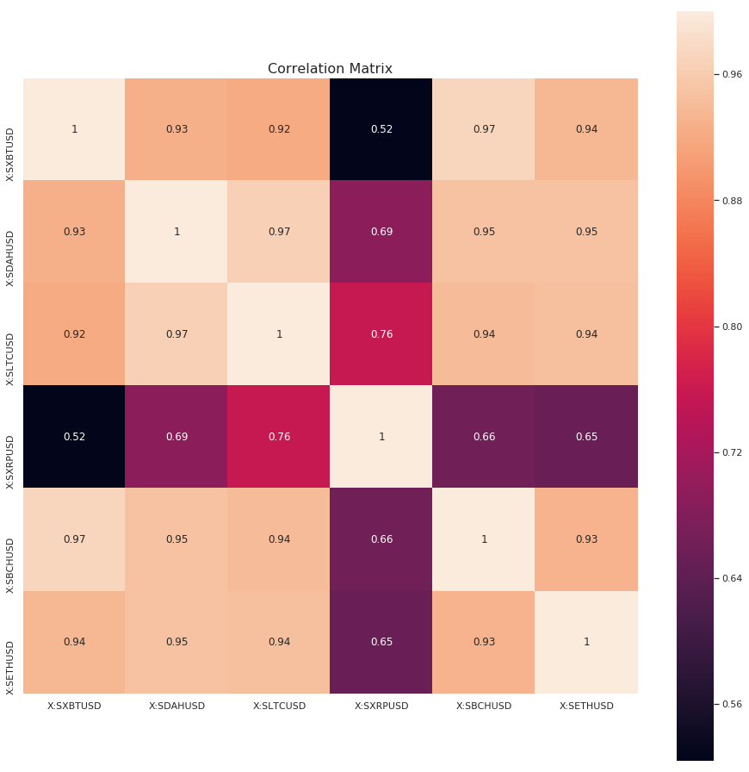

**Monthly wise Trade USD:**

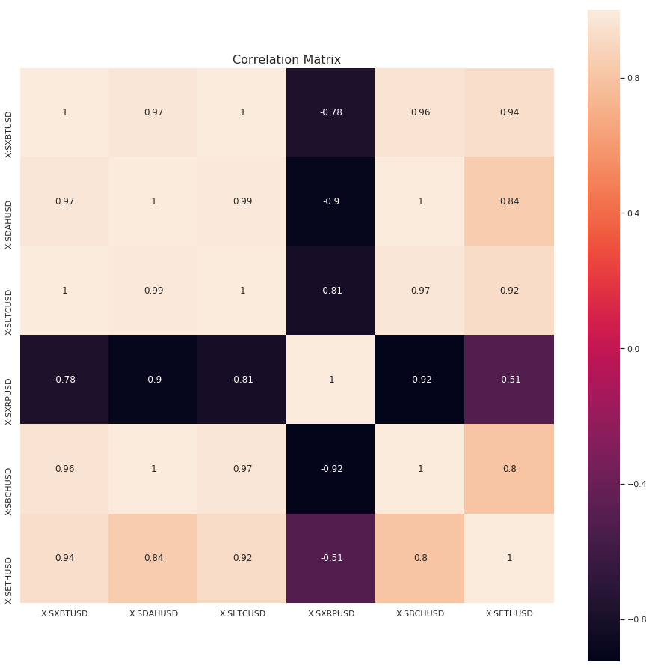

**Program 3.2**

**File name: ​phase3_3.2monthlywise，phase3_3.2weeklywise**

**Description:**

Find the correlation between trade volumes movements of different Spot Cryptocurrencies having same currency pair. Plot the heatmap for showing correlation values. Calculate correlation month-wise or week-wise

**Inputs(all set in the code, no need to input anything):**

Filetype ​: B

date​: the date in yyyymmdd format

ticker​: all pairs with available data

plot: heat plot

**Output:​** heatmaps of month-wise and week-wise

**Sample：**

**Weekly wise Trade USD:**

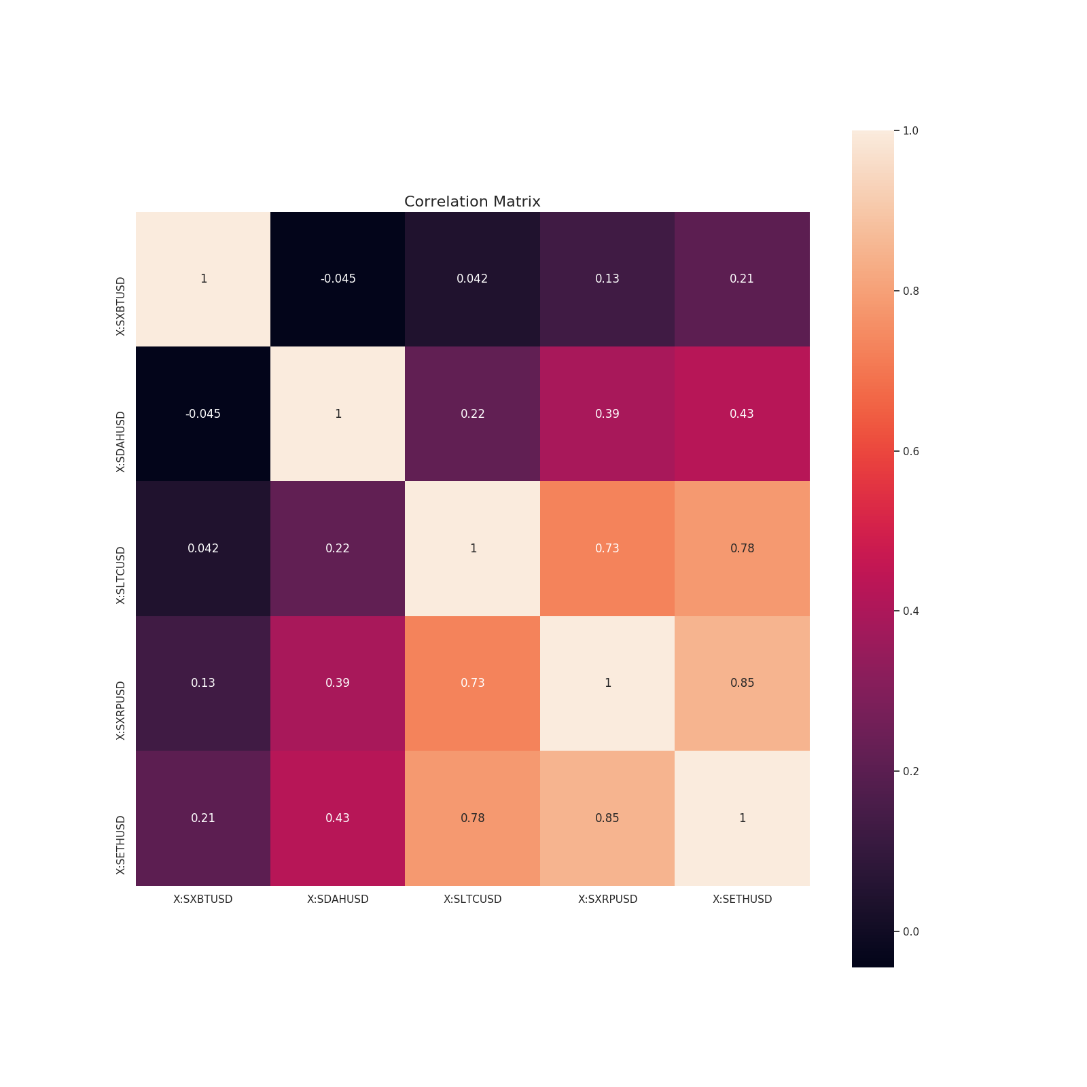

**Monthly wise Trade USD:**

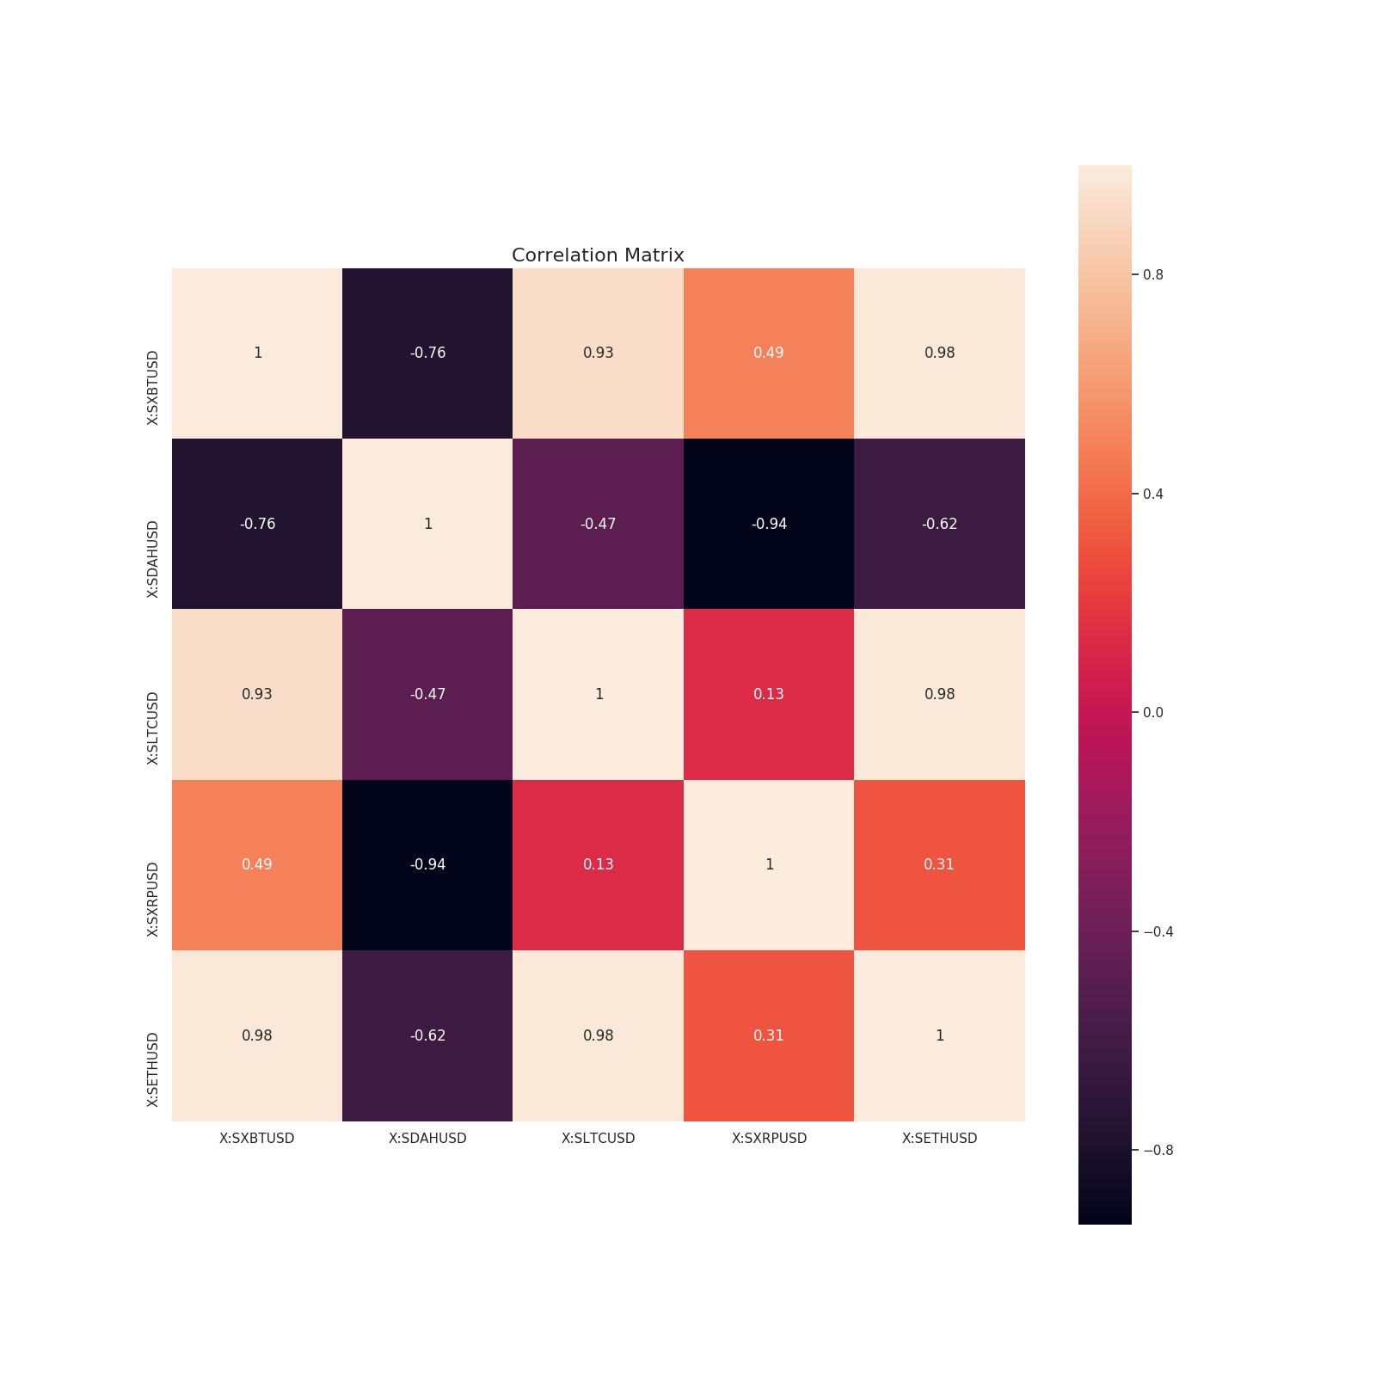

**Program 3.4**

**Filename:**​ problem3_4.py

**Description:**

Make plots in such a way that plot volume – traded volume or bid volume or ask volume – for any type of file available for a particular day for a particular instrument (in Futures files only Bitcoin matters) chosen by user.

**Inputs:**

Spot filetype: A (1619 Spot data 1) or B (1356 Spot data)

or C (666 Future data 1) or D(680 Future data2)

Date: in yyyymmdd form.

Future ticker​

Instrument: choose from instrument list

Option1: choose from Trade, Bid, or Ask

**Output:**​

For the selected filetype and the date, the output is a png file with spot filetype, future filetype and ticker in the name. All available venues are plotted together on one plot.

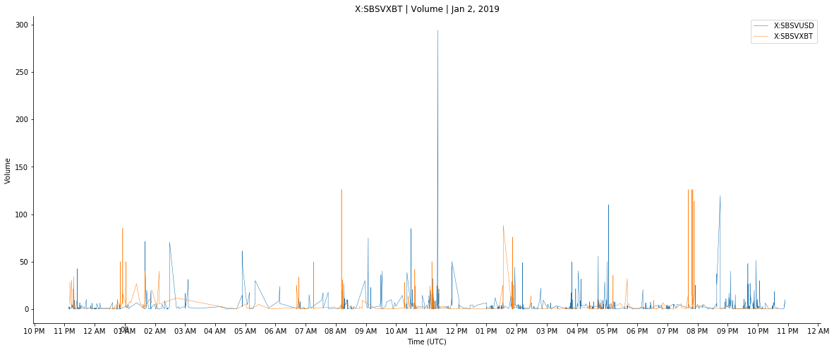

**Program 3.5**

**File name:** ​phase3_3.5

**Description:**

Plot average “monthly” standard deviation in trade prices of Spot cryptocurrencies like Bitcoin, Ethereum, Litecoin.

**Inputs(I have set down all the input so no need to input anything):**

Filetype ​: A or B or C or D

date​: the date in yyyymmdd format

ticker​: the pair to plot

**Output:**​ for now they are showed in the file the very end part.

**Sample：**

Plot average “monthly” standard deviation in trade prices of Spot cryptocurrencies like Bitcoin,

**Jan: Feb:**

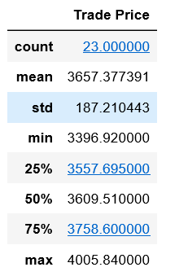 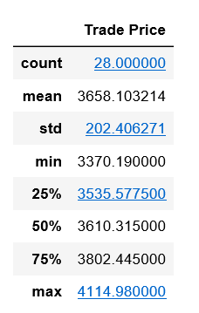

**March: April:**

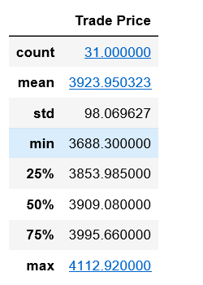 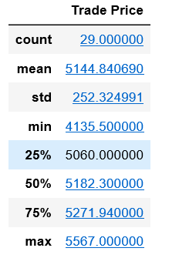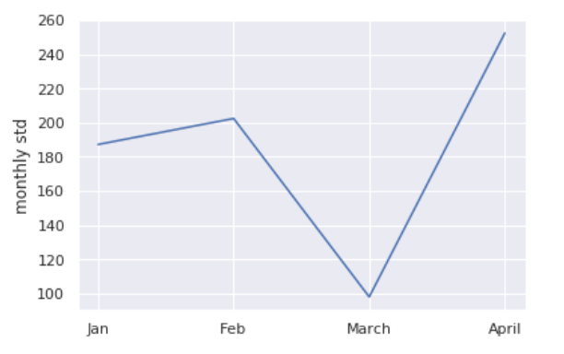

**Program 3.6**

**Filename:**​ problem3_6.py​; projfuncs36

**Description:**

Make plots in such a way that plot three prices mentioned below in a single plot for the given 4-month period (Jan-Apr’19):

1) Bitcoin Spot price [with option of selecting Spot-1 (Type A) or Spot-2 (Type B) file and selecting one exchange out of available exchanges] take daily close price for plotting.

2) Bitcoin Futures price [with option of selecting Futures-1 (CBOE) or Futures-2 (CME) file and selecting a Bitcoin Futures of a particular expiry date] take daily close price for plotting.

3) Theoretical Price of Bitcoin Futures calculated using below formula and the input (expiry date) provided by user.

The theoretical formula for calculating the futures price from the spot price is as follows:

Crypto-currency Futures Price = Crypto-currency Spot price * [1+ rf*(x/365)]

Where rf = risk-free rate on annual-basis = 0.02 (this value can be assumed for ‘rf’)

And x = number of days to expiry

Here in the plot limiting factor is the expiry date of the Bitcoin Futures. The graph needs to be plotted till the day on which Futures instrument chosen by the user expire.

**Inputs:**

Spot filetype:A (1619 Spot data 1) or B (1356 Spot data)

Future filetype: C (666 Future data 1) or D(680 Future data2)

Future ticker​

rf: risk-free rate on annual-basis = 0.02

venue: choose from available venue list

**Output:**​

For the selected filetype and the date, the output is a png file with spot filetype, future filetype and ticker in the name. All available venues are plotted together on one plot.